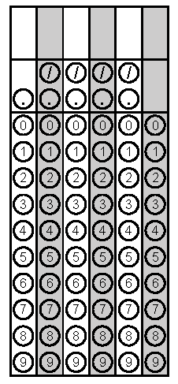

Each grid can be resized by clicking on the grid and dragging the corners outwards/inwards.

Each grid can be copied and pasted multiple times.

If aspects of the grid are difficult to see, you can click on a grid, then click format at the top of the screen and adjust the contrast of the image.

